Conference

The Catch Heaven’s Flame Conference will be held Thursday thru Saturday, December 1, 2 & 3, 2011, at Tigard Covenant Church in Tigard, Oregon.

Passionate “nation changing” evangelists are being brought into the Portland region to stir the fires of our hearts towards God, and for the harvest! Special emphasis will be on doing the works of Jesus, thru the power of the Holy Spirit, with boldness and understanding of who we are in Christ!

Our key note will be international speaker David Hogan with inspirational worship music by GodSong! Register online thru November 29th for only $20 per person or $30 at the door. Register through web at: http://www.wix.com/heartsoffireintl/catch-heavens-flame#!__register

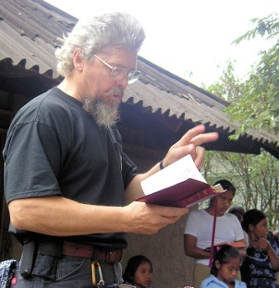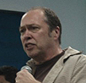
Deborah Gliebe
Evan Wiggs
Arron Winter
Timothy Sherman
David Hogan

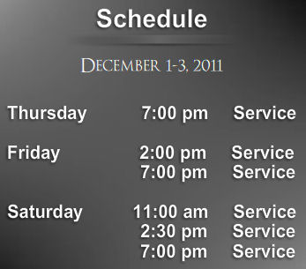

Tigard Covenant Church
11321 SW Naeve Street
Tigard, OR 97224
(CLICK FOR MAP)

